**How does Designing Assistive Technology with a Physical Therapist Help Older Adults?**

Uvonne Andoh

July 26, 2013

University of Maryland, Baltimore County

**ABSTRACT**

As the population of older adults increases, assistive technologies can enable a growing population of older adults to function independently and maximize their quality of life. These older adults, who rely on equipment for rehabilitation, can benefit from physical therapists printing customized and inexpensive assistive technologies such as grips, braces, and handles during appointments. The use of a 3D printer and the web-based program Google SketchUp will be used to design and build objects for physical therapists to assist their patients. Frequent interviews and design sessions with physical therapists were conducted to determine the effectiveness of this approach.

**INTRODUCTION**

Nearly 14 million older adults age 65 and older has a disability of some kind. Most disabilities seen within the older population tend to affect the life expectancy of older adults leading to a higher longevity rate within older female adults than men. Older adults who have any form of impairment tend to rely on technological devices that can help them function and regain independence. Currently, there is an improvement in the quality of over 25,000 assistive technologies out there on the market which serves older adults with numerous types of impairments. The high rate of long life within the older population has increased the need for assistive technologies in order to enrich the lives of the elderly. An effective approach to determine if older individuals are gaining from assistive technologies they use is to monitor the improvement of their quality of life, and there should be an ongoing support for older adults who are reliant on the devices to make sure they are receiving the proper care needed to help improve their health. Assistive technology is a growing way of supporting disabled older adults, promoting self-management, and independence with the potential to enable older individuals to accomplish tasks that were impossible. Geriatric physical therapists mainly focus on pain, strength, joint range of motion, endurance, and gross motor functioning of older adults through optimal physical performances, which requires reliable tools to assist their patients. It is also important to take into account and meet the diverse needs of all older adults when trying to enhance their quality of life with a device. The effectiveness of using assistive technologies primarily depends on whether the device is used as originally intended. If the device is not used as it is supposed to be then it reduces the efficiency and effectiveness of it. Additionally, older adults value their independence, hence being able to provide the assurance of regaining their sense of independence will help increase their life expectancy. One advantage of assistive technology in older adult’s lives is the promotion of a healthy and active life. Older adults feel confident when they know they can be assisted. This will decrease fear and social isolation older individuals face. Many of the elderly individuals rely on assistive and rehabilitative technologies to promote and improve their quality of life; such devices can be a lifeline to increase their biological, interpersonal, social, creative, and symbolic needs.

While Assistive Technologies can be portrayed as a positive mechanism ranging from numerous assisting devices such as wheelchairs, vision aides, walking sticks and many more in order to help older adults regain independence, and to have a sense of physical and emotional safety, there is also a downside on the user from data collected which normally leads to a sense of feeling embarrassed relying on technological devices. Cost as well leads to older adults being hesitant about using technologies to support them; the high cost of technology has led to standstill in older adults being interested in them. The less information and knowledge many older individuals know about such devices that can assist them should be strategized to increase and sustain the uptake of assistive technologies. A solution to eliminate the lack of knowledge older adults have about technologies, is by training them to use assistive technologies in order to help them understand the benefits of these devices as well as the potentials it can offer to their life. The rapid demand of new and improved assistive technology is causing older adults to under appreciate existing technologies since there is always an improvement and an increase in the cost of such devices. Most users’ on the other hand, waste money and time on purchasing new technologies that are less effective, which in turn leads to a doubt in the reliability of  how current assistive technologies shapes their idea of improving a better life and recovery process. A solution to such abandonment in assistive technologies is to teach users how to design and build their own assistive technologies instead of relying on the products others make on the market. This in turn emphasizes users to control problematic factors and become more knowledgeable about the technology that they use.

3D printing is a form of additive manufacturing that makes a three-dimensional solid object virtually from a digital model. The advantage of additive manufacturing is the idea that it uses the exact material needed to print an object as compared to subtractive manufacturing which involved drilling, cutting, and also sawing into materials in order to produce an object leaving waste of materials behind. 3D models hence, are achieved through additive process were thin layers of melted plastic materials are laid in many shapes to create a 3D object. Studying how designing and printing 3D models with the help of a  physical therapist by creating and modifying customized and inexpensive tools can help the older population.  Physical therapists mostly rely on various mobility aides such as walkers, canes, crutches and braces in order to assist their patients in recovery. Engaging physical therapists in learning how to use 3D printers with the outcome of designing and printing their own tools for their patients will eliminate relying on products on the market which they have no control over. Moreover, older adults can also learn how to design and build their own objects for rehabilitation. Older adults being able to print 3D tools on their own will reduce dependency on their physical therapist to provide them with the necessary tools.  Because many older individuals cannot afford to see their therapist every week, getting them involved and teaching them in designing and building models using 3D printers will be beneficial and effective for them. This will also help them to feel a sense of independence during the times they cannot schedule an appointment with their therapist, this will also make the lives of physical therapists easier reducing their work load. There is practically a little limitation with 3D printing, objects that are printed out can take the size of the printers late where the object is built on in terms of width, objects cannot be printed out that is wider than the width of the plate. Although objects are limited in that sense the height of an object moreover can be printed out taller, but basically the only limitation associated with 3D printing is your imagination.

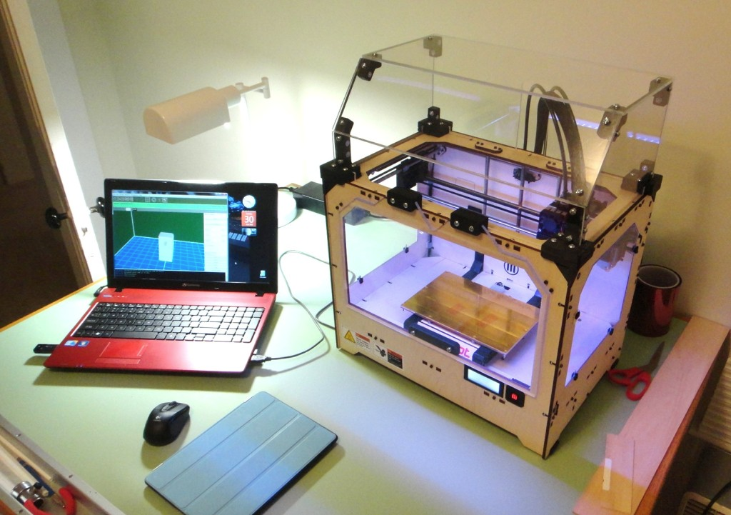**Potential 3D Printer in a Physical Therapist Office**

There are many benefits of incorporating 3D printing into the work of a physical therapist and older adults such as affordability for older adults with limited funds. Many older adults feel that rehabilitation is merely ineffective and therefore 3D modeling can add a more positive social interaction for them, while incorporating a more creative way for physical therapists to make their tools appealing in comparison to traditional tools. Determining how physical therapists can help in 3D designs to facilitate their help to older adults will pave a way for older individuals to have a positive mindset about assistive technologies.

This research will also focus on how older adults might respond to such tools being printed out and used on them by their therapist during appointments, and how the impact of a physical therapist can help overcome any limitations due to any functional restrictions older adults may face, hence improving a much more feasible quality life for them.

**LITERATURE REVIEW**

The use of assistive technologies by people with any form of disability can improve their wellbeing and daily activities. Although assistive technologies enable individuals to improve on how they function, there are also limitations that hinder older adults specifically from using such technologies. One of the drawbacks older adults might face using new assistive technologies is the little knowledge and familiarity they may have with technology. (Brandt & Alwin, 2012). However, training the older population on how to use assistive technologies can minimize their hesitant to being exposed to something new, and will increase their independence.

In “Technology in Everyday Life of Older Adults,” Burdick and Kwan (2004) conducted a study to determine the burdens in introducing new technologies in the lives of older individuals who may suffer from physical impairment such as arthritis and their unwillingness to adapt to new technologies. The significance of their study showed that older adults who are exposed to new technologies might have difficulties at first due to their lack of knowledge. The necessary training offered to older adults can help them familiarize themselves with the technology they use which will make them feel comfortable. Additionally their solutions gave rise to increase the independence among the elderly. The authors provided evidence indicating that assistive technology increases the quality of health and reduces mobility impairment within the older population.

In their study Courtney, Demiris and Hensel (2007) place emphasis on the high demands of assistive technologies within the older population as the numbers of older adults grow rapidly. Incorporating assistive technologies in the lives of older individuals will increase their life expectancy allowing them to regain their independence. They explain the importance of older adults being exposed to assistive technologies as it improves their quality of life. They stressed on the fact that having assistive technologies in residential care facilities increases functional independence.

Mauk, (2012), explains the importance of developing communication skills with older adults, she emphasizes on the fact that an effective communication, especially with older individuals with cognitive impairment, helps them with their everyday needs. Her study is important because it explains how important effective communications with older adults who are disabled and vice versa can help eliminate any misunderstanding and can help caregivers to understand and provide for the elderly. The author also expresses the importance of communication especially when working with disabled older adults and offering ways to improve and help them and their caregivers to effectively and efficiently communicate. (Mauk, 2012).

Patomella and colleagues, (2011), speak on the everyday use of technology and how it can help older adults to connect and keep in contact with family members and friends. The authors also talk about older adults who have cognitive impairments and other difficulties can benefit from assistive technologies in their lives because it can help them with their wellbeing and interact and participate in society (Patomella et.al, 2011). Patomella, Kottorp, Malinowsky and Nygard explain the physical, cognitive and social aspect of older adults and how assistive technologies can affect their interactions and also some of the implications and difficulties derived in designing technologies for the elderly.

In contrast, Pavel, Jimison, Hayes and Kaye, (2009) emphasis on the importance of introducing technologies to the older population to improve quality of life, and to enable proactive health care. They dissect the behavioral, physical and cognitive functionality of older adults and how the impact of technologies can decrease dependency. Furthermore, they show how an older adult’s life depends on assistive technologies to aid with their daily lives and help them regain independence.

It appears that Assistive Technology can bring about safety and quality of life to older adults with functional impairment. Assistive technology thus has paved a way for older individuals to feel a sense of independence and has reduced their risk of isolation. Incorporating customized 3D models with the help of a physical therapist as a form of assistive technology to the everyday lives of older individuals has the potential to limit functional independence and increase their biological, societal, interpersonal, creative and symbolic needs.

As the world is gradually depending on technology for everything, it is beneficial to integrate 3D printing, a form of assistive technology into their lives. This on the other hand will ensure that individuals are aware of the possibilities and advantages of such devices. Not only will this inform people about the printer it will serve as an eye opener to understand the significant role of 3D printing. 3D printing is not only seen as a fun device to work with, but also it serves as a solution and opportunity for individuals to express and improve on their ideas creatively.

**RESEARCH OBJECTIVE**

The proposed study aims to develop Assistive Technologies for the older population through rapid prototyping tools enabling older individuals to possibly build and customize. The overarching goal of this research is to incorporate 3D printing into the lives of both physical therapists and older adults’ lives in order to determine the value of these devices. The importance of educating physical therapists about customizing and building inexpensive tools with the use of a 3D printer is the fact that it offers new opportunities to assist and meet the needs of their patients whiles with older adults; it limits distress especially when they cannot meet with their physical therapist on a regular basis. Therefore teaching them to build and design their own tools will be beneficial by reducing such dependency on therapist. Introducing older adults to the possibility of designing their own workable tools provides a creative solution to be productive, and independent. Educating and having regular training sessions with physical therapists and older adults about the possibilities of assistive technologies gives rise to create an umbrella of making the impossible possible.

The misconception about assistive technology is the fact that older adults become attached and dependent on these devices. This does not allow them to function on their own, drawing the issue of it being high tech making it expensive for older adults to afford on their own. Teaching older adults how to design and build their own devices will help them to be less dependent on therapists and caregivers for all their needs. Therefore, introducing, them alongside physical therapists to 3D printing will pave a way for new ideas in both the improvement and ideas of things to be built to suit their individual needs. Another goal of this research is to combine various strategies in educating people about assistive technologies which can significantly improve and increase access to new experience. Giving regular demos at libraries is a way of generating ideas and educating the public especially targeting the older population about these new and innovative devices, which on the other hand generates ideas that will be beneficial for designing tools for physical therapist to try on their patients.

The following research question will guide the proposed research.

How does the structural motive assess the effectiveness of the research?

The techniques used to effectively and efficiently carry out the proposed will enable physical therapists to develop knowledge about the success of the tools they design for their patients. This will also enable them to have control of any limitations that might be derived from creating their own Assistive technology. In order to assess the effectiveness of this research, frequent informal interviews and meetings has been conducted and structured with physical therapists in order to have a clear understanding of the types of equipment used, and also analyzing what they make. The interviews focused primarily on how physical therapists currently use assistive technologies to help older adults overcome limitations due to functional restrictions. It also involved having physical therapist come up with ideas on the tools they would like or be interested in printing out for them to determine if their engagement about 3D printing will be of interest and benefiting for them on the outlook of their job now and in the near future.

**HYPOTHESIS**

Older adults with motor, cognitive and sensory impairments will prefer to use assistive technology they designed and built over off-the-shelf medical devices.

**Research questions include:**

1. What assistive technologies are physical therapists currently making, and how are they making them?

2. How do assistive technologies enable disabled older adults to function better?

3. How do therapists assess the potential of the technology? How is this equipment evaluated?

4. How do older populations determine the value as assistive technologies?

5. How will using rapid prototypes be most efficient to design assistive technologies?

6. How does the structural motive assess the effectiveness of the research?

7. How do older adults feel about designing and building their own assistive technologies?

**METHODOLOGY (PROCEDURE)**

This proposed study intends to use a primary source of data collection through frequent interviews and design sessions with physical therapist and older adults. A secondary approach of the research project is giving regular demos at the arbutus library to help generate ideas of what older adults might be interested in making for them using the 3D printer. Apart from doing demos to interest the public, it serves as a means of educating people about 3D printing and on how to design and build their own assistive technologies at a low cost without being dependent on expensive assistive technologies on the market. Data was collected by interviewing three physical therapists in order to evaluate the types of equipment used, and analyze what they make specifically for the older population who are their patients. The specialty of the therapists interviewed were geriatric physical therapists that had five to twenty years of experience in the field with the highest education in a bachelor’s degree and physical therapy school and training experience. The interview served as a pathway to develop solutions to problems physical therapists face on a day to day basis with their current tools. Some characteristics that were taken into account during the interview session of the project were age, experience in field as well as specialties. Race, gender and ethnicity were not looked at in terms of which therapist will be interviewed, those characteristics did not play a role in determining the outcome of the project. On the other hand, with the demo groups, some of the characteristics looked at was who attended, the ratio of men versus women, age, and socio economic status. Because the demo was opened to the public each demo sessions was unpredictable, there were different set of age group during every demo sessions.

After the completion of the interview regular meetings with the three physical therapists were held in order for them to come up with ideas on the tools they wanted to be designed and built to use on their patients. Furthermore, the structure of the interview was categorized in specific topics and sections for flexibility to acquire a detailed response to gather as much information as possible. Some of the possible categories and questions asked during the interview included:

**I. Background: Why Physical Therapy?**

1.) What influenced you to study physical therapy?

2.) Why do you think physical therapy is such an important factor in helping individuals with minor or major injuries?

**II. Who are your patients?**

1.) What kind of physical therapy do you practice?

2.) What are the most types of injuries you see in your clinic?

3.) Do you think there are any patients that need your services but because of the lack of resources, you or other physical therapists are unable to assist them in their needs? These could be individuals who have disabilities or lack of insurance. And what would you suggest for these patients?

**III. Steps taken to satisfy patients?**

1.) In your view, what is the most important part of helping your patients?

2.) What are some of your outcomes you expect out of assisting your patients?

3.) What was one of your most complicated cases in which you had to seek outside help in order to help your patient with their injury or disability? What did you do in order to assist them?

4.) What are some of the obstacles that deprive you from assisting your patient to your full ability?

5.) Would you be willing to learn about ways to avoid such obstacles?

**IV. What should be built for Patients?**

1.) Many physical therapists build their patients devices that are helpful with their rehabilitation. Have you ever thought of products that would benefit your patients?

2.) What would you recommend to be a beneficial product for all physical therapists to invest in?

3.) Have you built this product based on your idea? What sources do you use?

4.) What other products have you built to assist patients, if any?

5.) What are your experiences with the products you have used or had built? What ways would you change them?

6.) Would you be willing to try any products that will be designed and built order to ensure that your patients recoup from their injuries? Or try a device that would assist your patients with certain disabilities?

8.) What are the common types of tool/equipment you use to assist your patients?

9.) Do you have others make your product or do you have a team that makes specific products for you?

10.) Roughly, what are the costs of the tools or equipment you use on your patients?

**V. Conclusion**

1.) What are the advantages and disadvantages of being a physical therapist?

2.) What advice would you give in order to build your clients useful products that will help their well-being of life?

A recorder was also used to clearly capture the responses of the physical therapist.

Moreover, the 3D printer and software used to design the tools for both physical therapist and older adults are very important. The first stage of 3D printing any design is to have an idea of what the design is supposed to look like with the help of a computer aided digital design model or an animation modeling software, which in this case was Google Sketch Up. After creating a virtual blueprint of the object wished to print, the program translates the object for the printer to print in layers. The object designed is now downloaded into a language the printer can understand which is the stereolithography or standard tessellation language (STL). The STL file is then transferred to a generator code called ReplicatorG which comes up as the model or code designed. After the model is generated one can choose to download the object on a regular memory card. The card is then inserted in the printer to command it to print the object in layers (The Wall Street Journal, 2013). The materials used to print are either acrylonitrile butadiene styrene plastic (ABS) or polylactic acid (PLA) which are both thermoplastics, the same plastics Legos are made off. The common difference between the plastics is that PLA plastics are stronger than ABS plastics and also ABS plastics tend to shrink when used to print (Bitsfrombytes.com).

Hence, after the completion of numerous demos, exposing the possibilities of 3D printing to the public, the interest level of individuals raised so as the curiosity level. The dedication of collecting data with doing demos gave chance to make the ideas people had to print come into reality.

**Demos at the Arbutus Library**

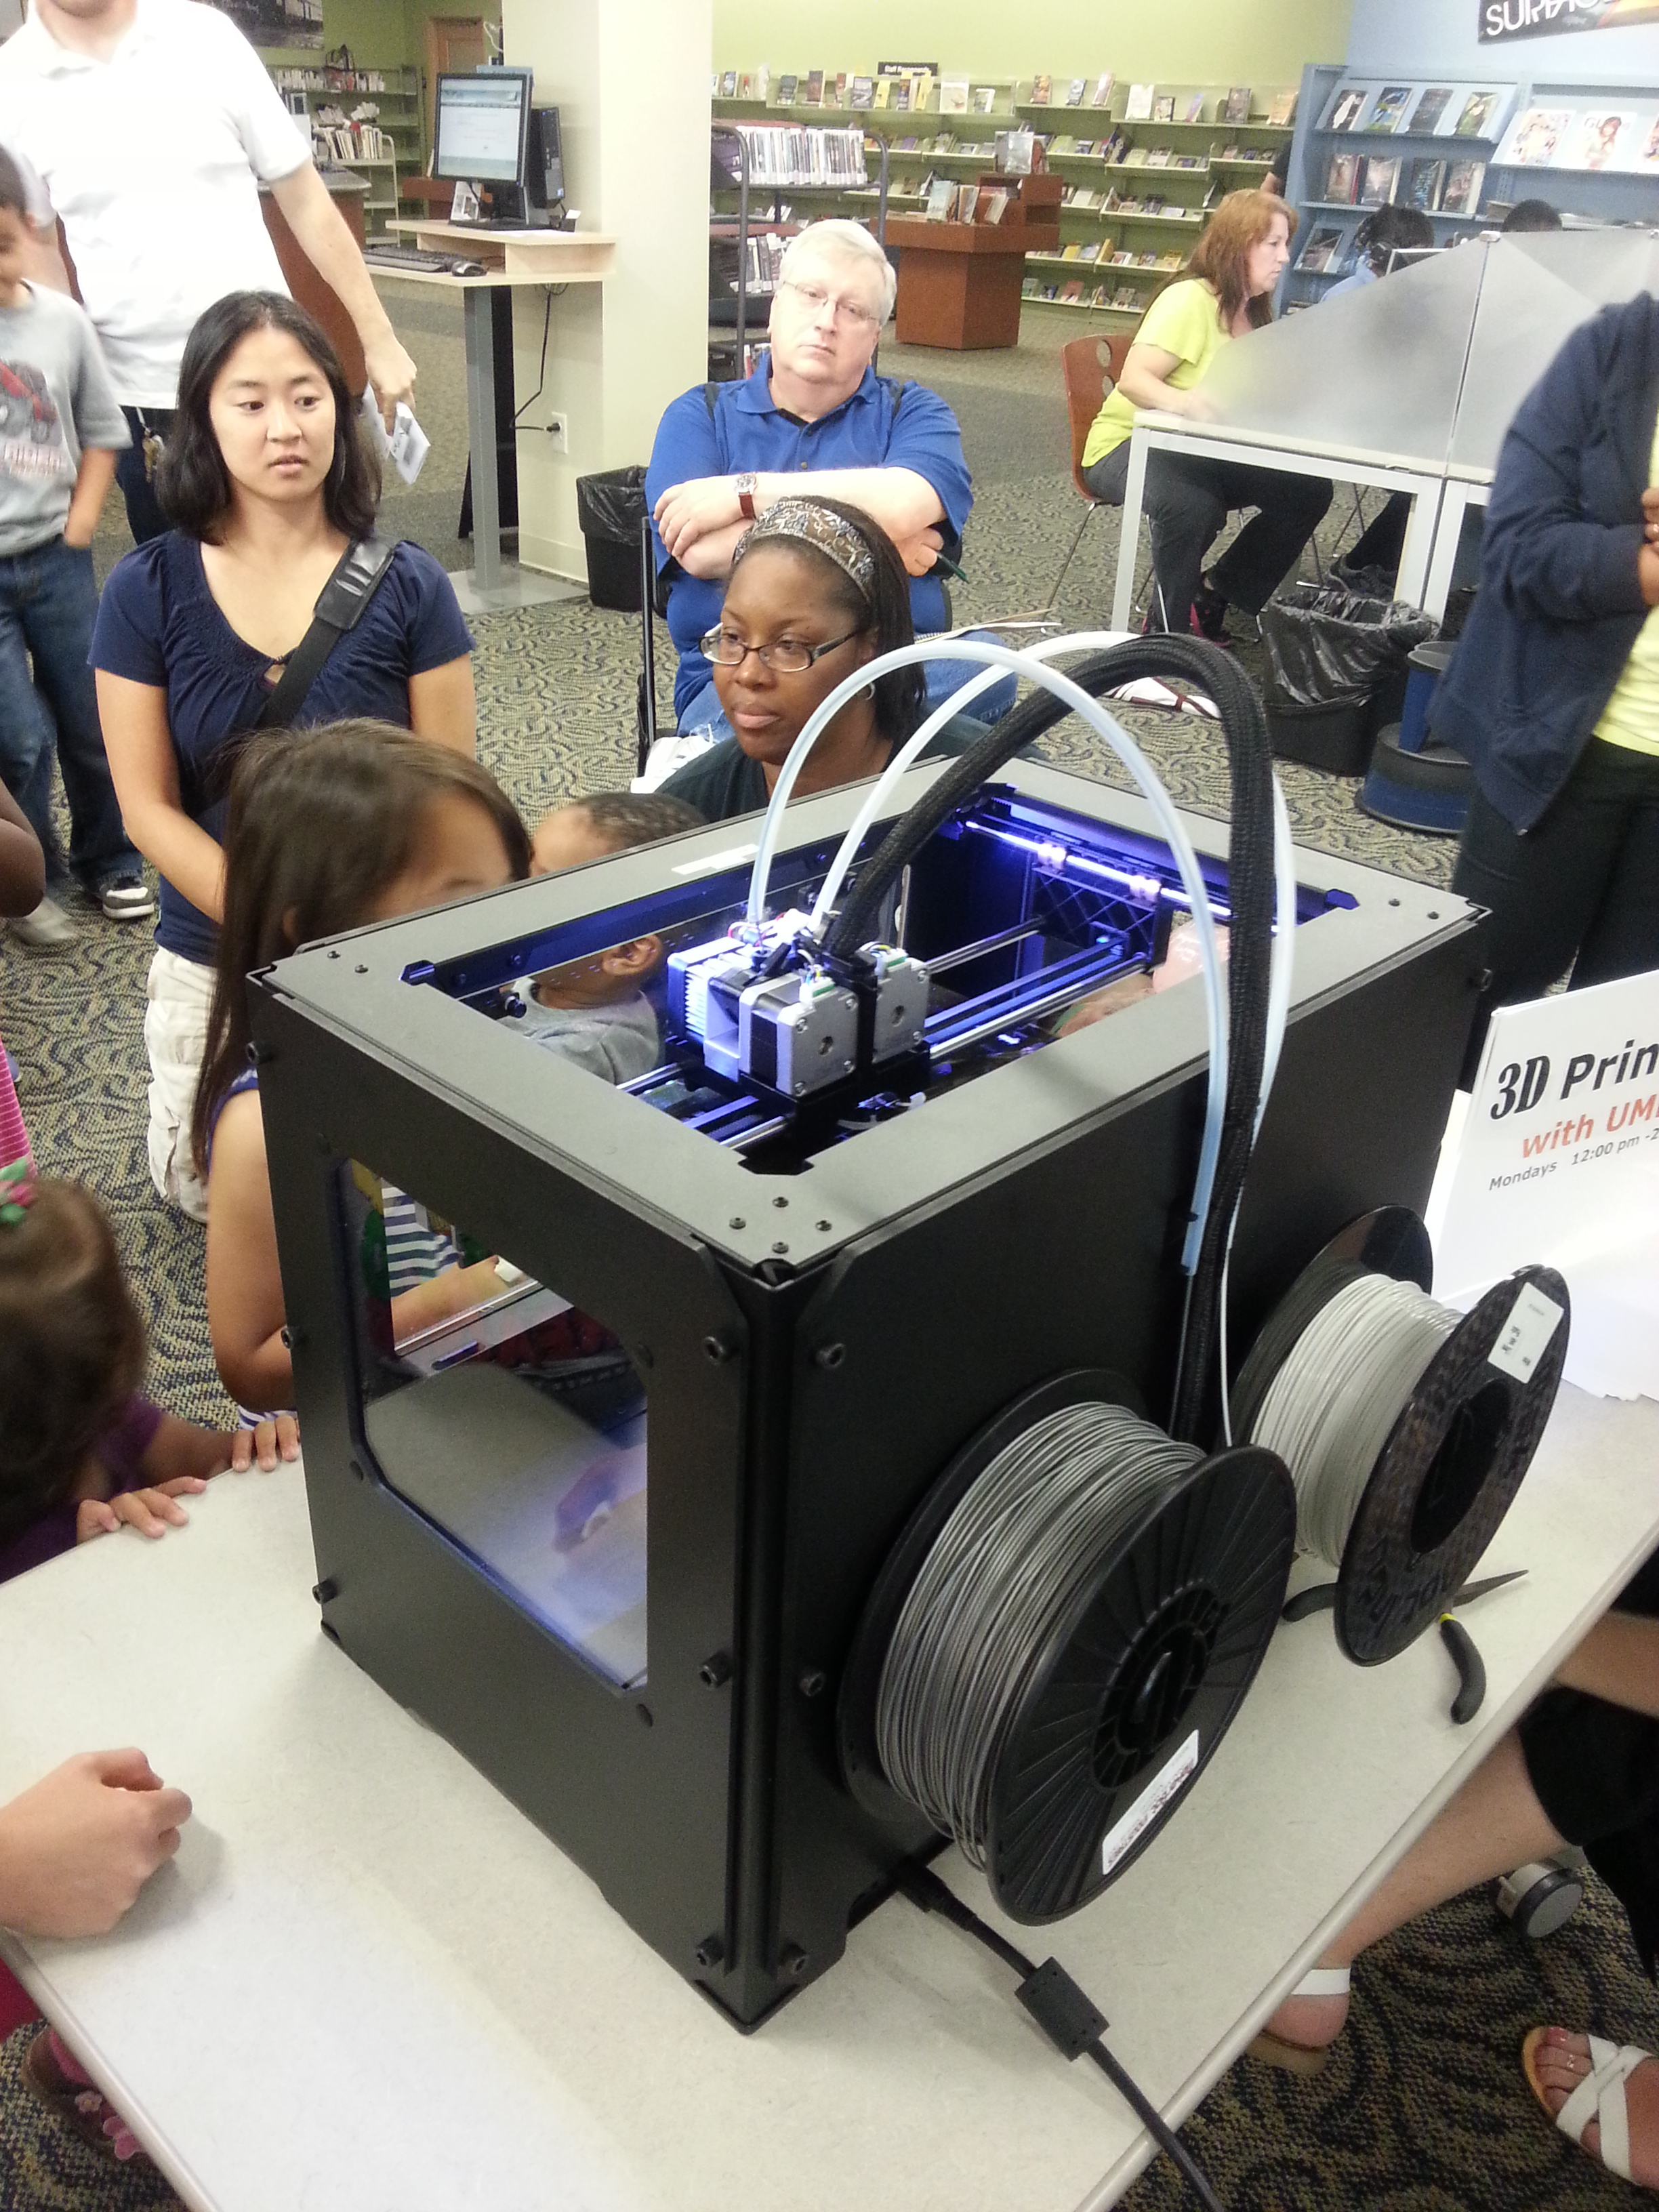 nnDe D

Demonstrating the 3D printer to a mixed audience of older adults, children, young adults and middle aged adults has helped with a diversity of feedbacks to better accommodate the different groups of people during the demo. The primary purpose of having a demo once a week is to spread the knowledge of technologies that can be used by anybody regardless of the amount of technology background a person has, and to also teach the public about being able to design and print their own objects ranging from medical objects, toys or customized objects that could not be purchased anywhere else on the market

Despite the fact that 3D printing is relatively new, the step taken and of demoing to the public can help people to improve on design skills, for example an older adult who was really good at designing can improve on the skills once again by learning how to use the 3D printer. 3D printing can also help broaden imagination, being able to turn in the head into a reality which help in motivating people to step outside the box as the only limitation dealing with 3D printing is the mind. Although 3D printing is at its infant stage, the benefit of constantly educating the public about it and making them aware of the printer, the more people will get to know and be familiar about this device and more ideas will be presented on what can be made and how the printer can be improved in our daily lives.

Data was collected in three ways according to the following schedule:

April, May 2013: First interview with three physical therapists

June 2013: Second interview and regular meetings for a follow up. Gave

3D printing demos and coming up with questions and ideas to

build objects for physical therapist to use.

July 2013: feedback was given on the effectiveness of 3D models.

Physical therapist and older adults became familiar with the

Printer and the things the printer is capable of building.

The interest of 3D printing from the public helped to acquire

data

The first step of the interview explored and evaluated some of the tools physical therapist use to assist their patients as well as to better understand the needs of physical therapist by exploring the possible ways of introducing 3D models to effectively help their patients and enhance their tools.

The second potential interview was conducted to help understand the job and demands of physical therapist and develop ideas on what 3D prototypes to design and build to assist their patients. Alongside a demo session was set up to educate older adults on the possibilities of assistive technology through 3D printing. This second step also taught older adults how to create and build their own assistive technology at home without necessarily going to a physical therapist every time especially if they cannot afford to have regular appointment with their therapist. The third step was providing the opportunity to design and build 3D models physical therapist require and need for their job in order to try it on their patients to determine how effective and reliable the 3D printer and the tool printed out is, and also if they will be interested in learning more about it with the potential of having the printer at their work place.

**RESULTS**

At the end of this research there will be a better sense of how 3D printing can be used by physical therapists, and hope that a physical therapist will test models designed and printed for them on their patients. The potential outcome is for physical therapist to learn how to use the 3D printer to design and print their own tools without relying on tools already on the market. Offering them background knowledge about what 3D printers can and cannot do is vitally significant. Having the 3D printer in their work environment will make it easier for physical therapists to print objects needed for rehabilitation and graceful aging. Incorporating 3D modeling into the life of a physical therapist is feasible since it limits the cost of equipment parts and proves to be much easier. On the other hand, the expected outcome for 3D printing in the lives of older adults is for them to have the knowledge about 3D printing and learn how to use these devices to print their own 3D models on their own with the potential outcome of them having the printer in their home when they need a tool or object, instead of being dependent on both their therapist and products already made. The goal is for older individuals to be constantly make their own object and not grow weary of the printer so therefore constantly educating them about the technology as it improves will help them to not abandon the devices.

From analyzing and interviewing physical therapist on what they make, designing working tools with the printer and getting feedbacks has helped to generate more ideas. After constant designs and printing of various tools for physical therapists, there has been an interest in the idea of 3D printing due to the affordability of the printer. The feedbacks gotten from the physical therapist has helped better and clearly know the tools physical therapist are most interested in making for them or making on their own using the printer, the feedback also helped to redesign tools suitable for the therapist in order to make them comfortable while using the tools. The purpose of doing demos is to also educate the public who are not familiar with 3D printing have a general idea about what 3D printing is and what benefits it has in their lives.

**Customization of Note Holder**

 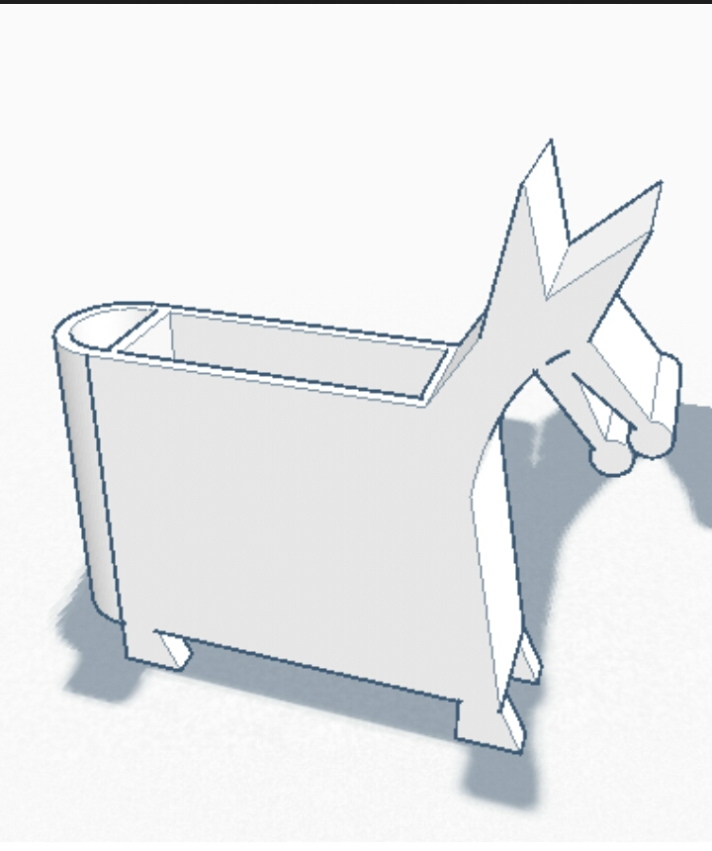

Customization is an important aspect of 3D printing, as one can produce personalized or tailored-objects suitable for their needs. The picture above is an example of taking an original object and customizing it to meet the needs of an individual, the picture on the left is an original object sold on the market, while the picture on the right is a replica of the original object which was designed using an online design software and adding and changing different aspect of the original object to create a similar object. This can reduce the cost of going to buy an object already designed on the market as compared to designing your own object and modifying it to your own comfort.

**Customized Note Holder**

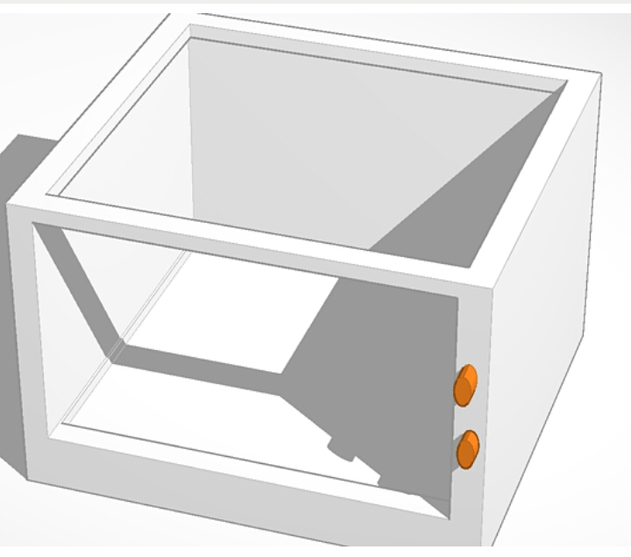

The picture above is an example of a customized object that was designed and printed out using the 3D printer is a note holder. This note holder above was made for an older adult at a demo who had a picture of an original note holder purchased on the market but wanted it customized and printed out using the 3D printer. Due to the high cost of objects or items sold on the market, it was easier and cheaper to have the object designed and printed out without spending money on it. Not only does this eliminate cost it also helps to illustrate creativity. 3D printing provides personalization and individualized services which help industries, artists and even individual consumers to make their ideas into physical reality which was rarely possible. With the possibility of creativity and customization, 3D printing has revolutionize the idea of consumer culture, it has led to consumers to be artistic and creating unique objects at a low cost compared to retail price. The concept of 3D printing helps to experiment and improve upon ideas for a better product.

3D printing will be easier for individuals to learn 3D printing for themselves without being dependent on others. The great thing about 3D printing is the fact that one does not have to be a tech savvy in order to use these devices; it is easy to grasp the basic concepts of using the device it is a great tool to save money. And overall, the expected results with the demo is to get as many people as possible to be interested in 3D printing and to learn more about the advantages of assistive technologies and how it can shape their everyday lives. This strategy will lead people to invest both their money and time into 3D printing allowing them to be more informed about upcoming technologies. Having a 3D printer in one’s home is significant especially in today’s society where everyone relies on some form of technology to practically live.

After having numerous design sessions with physical therapists and printing out tools for them to use on their patients, being able to get feedback on the tools helped to identify and solve problems that might not have made the tools as effective as it should be.

**Parametric Physical Therapy Tool**

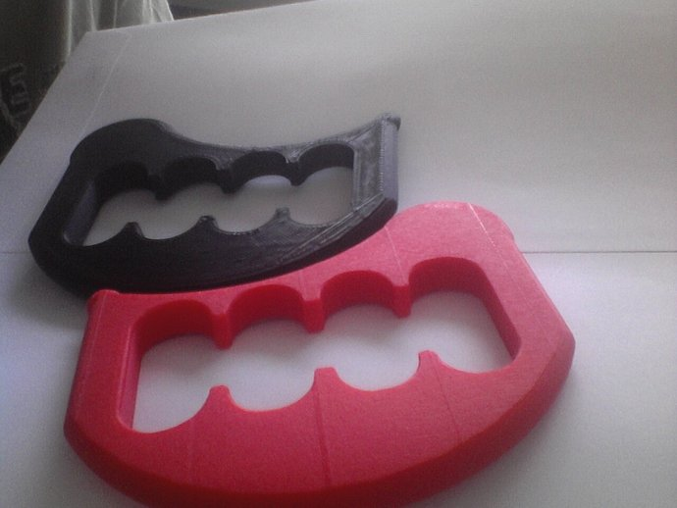

An example of a tool printed out, which was used on patients, was the parametric physical therapy tool for soft tissue manipulation. This type of customized tool is perfect for force progression for physical therapist to reduce pressure from their hand while working with their patients. The advantage of the parametric tool is the fact that it is customized for every individual’s hand size for an easy grip. Being able to print this tool for physical therapist to use on their patient with feedbacks helped me to make changes to the design to properly fit the hand of the therapist in order to make them feel comfortable while using the tool. The only problem with the tool was the little space in-between the actual tool to fit the therapist fingers. Therefore modifying the tool for the therapist helped it to be a useful tool to interest the therapist.

All physical therapists interviewed gave the same responses on terms of the lack of knowledge they knew about 3D printing and if 3D printing will be a reliable device that can be incorporated into their work. The amount of information received about 3D printing and the possibilities of customizing tools to be used on their patients gave offered a sense of curiosity on how the tools can work and in what way it will assist their patients. The results gotten from both the interview and design sessions supported the information received from the literature reviews. From demos conducted, and review of the literature review compared to the overall results gotten from physical therapist and older adults, 3D printing as a form of assistive technology has the potential to serve patients with various needs. The limitation of the printer on the other hand, is the fact that it is relatively new. There are improvements to be done to better print 3D models faster and bigger for physical therapists to use. As 3D printing advances in twenty years from now, there will be easy access to all individuals regardless of age. 3D printing has the potential to play a huge role in the field of aging, as the population of older adult’s increases; the demand for assistive technology will also increase. The printer will be an easy device to navigate around and use by the older population with less complexity to deal with. The device will also serve as a tool for a growth in the independency rate within older adults, as it is more engaging in all aspects of life ranging from biological, interpersonal, societal, creative and symbolic needs.3Dprinting will improve the efficiency of health for older adults and minimize the amount of money older individuals tend to spend on assistive devices.

**Bibliography**

Brandt, A., & Alwin, J. (2012). Assistive Technology Outcomes Research: Contributions to

Evidence-Based Assistive Technology Practice. Technology and Disability, 24(1), 5-7.

Burdick, D. C., & Kwan, S. (2004). Technology in Everyday Life of Older Adults. In

Rogers, W., Mayhorn, C & Fisk, A (Eds.), Gerotechnology research and practice in technology and aging: a textbook and reference for multiple discipline (pp. 7-17). New York, NY: Springer.

Courtney, K., Demiris, G., & Hensel, B. (2007). Obtrusiveness of information-based assistive

technologies as perceived by older adults in residential care facilities: A secondary analysis. Journal of Medical Informatics & the Internet in Medicine, 32(3), 241-249.

Fisk, A. D., Rogers, W. A., Charness, N., Czaja, S. J., & Sharit, J. (2004). Towards Better

Design for Older Adults. Designing for older adults: principles and creative human factors approaches. Pp. 3-19.

Mauk, K. L. (2010). Therapeutic Communication with Older Adults. In Stevens, K (Ed.),

Gerontological nursing: competencies for care. Boston: Jones and Bartlett Publishers.

Nay, R., & Garratt, S. (2009). Older people: issues and innovations in care. Sydney:

Churchill Livingstone/Elsevier.

Oishi, M. M., Mitchell, I. M., & Loos, H. F. (2010). Design and use of assistive technology

social, technical, ethical, and economic challenges. New York: Springer.

Patomella, A., Kottorp, A., Malinowsky, C., & Nygard, L. (2011). Factors that impact the level

of difficulty of everyday technology in a sample of older adults with and without cognitive impairment. Technology & Disability, 23(4), 243-250.

Pavel, M., Jimison, H., Hayes, T., & Kaye, J. (2009). Technology in Support of Successful

Aging. The Bridge, 39(1). Retrieved from National Academy of Engineering of The National Academies website: <https://www.nae.edu/Publications/Bridge/TechnologiesforanAgingPopulation/TechnologyinSupportofSuccessfulAging.aspx>

Shultz, K. S., & Adams, G. A. (2007). Age and Technology for Work. In Charness, N., Czaja,

S., & Sharit, J (Eds.), Aging and work in the 21st century. Mahwah, N.J.: Lawrence Erlbaum Associates.